**Pizza sales SQL Queries**

**KPI’s**

1. **Total revenue**





1. **Average order value**





1. **Total pizza sold**





1. **Total orders**





1. **Average pizzas per order**





**Daily Trend for Total Orders**

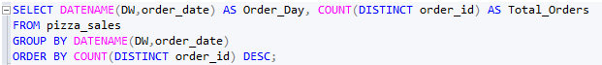

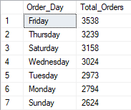

**Monthly Trend for Total Orders**

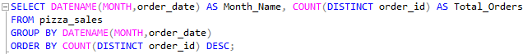

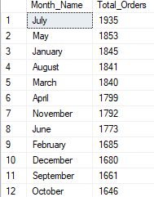

**Percent of sales by pizza category**

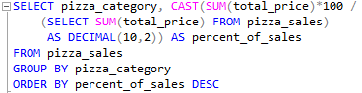

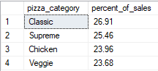

**Percent of sales by pizza size**

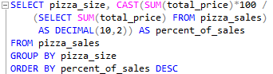

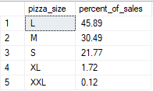

**Total pizzas sold by pizza category**

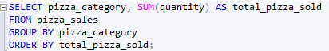

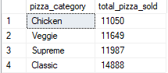

**Top 5 Pizzas by revenue**



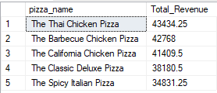

**Bottom 5 Pizzas by revenue**

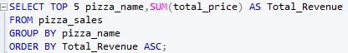

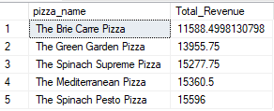

**Top 5 Pizzas by quantity**



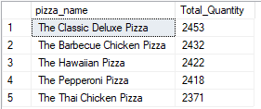

**Bottom 5 Pizzas by quantity**

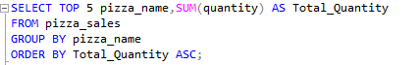

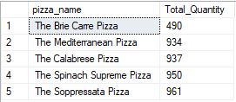

**Top 5 Pizzas by total orders**



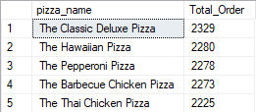

**Bottom 5 Pizzas by total orders**

